Apra 2025 Annual Convention is committed to providing universal access and welcoming guests of all abilities. You may submit a request for an accommodation through the registration form, or you may email bprais@aprahome.org for specific question. You can also review the hotels Accessible Features here on their website and additional hotel ADA features here.

What Dietary Restrictions are offered?

All meals will have gluten free, vegetarian and vegan options. During the registration process please submit your dietary restrictions so we have an accurate headcount. If you have a different restriction from the above, please submit your request and we will do our best to accommodate.

Where are the accessible paths of travel located?

There is wheelchair accessibility to all meeting space. See diagrams below of elevator access highlighted with a yellow dot.

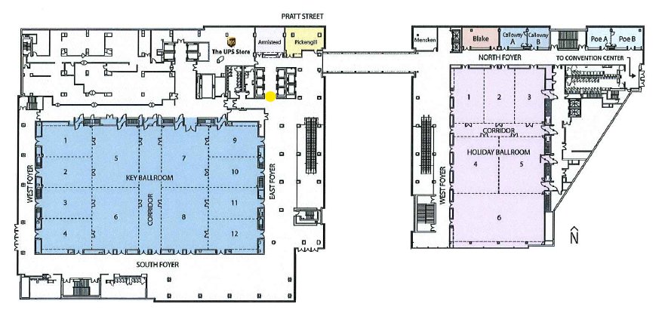
2nd floor (above), 3rd floor (below)

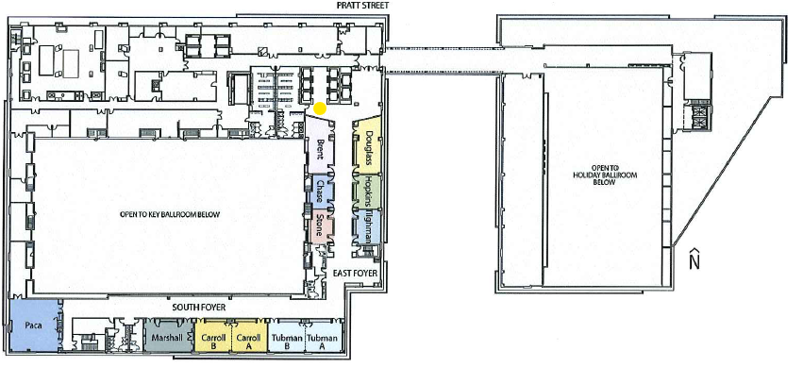

Furthermore, to the right of the elevators you will see two standalone elevators which are used only for access to the convention space, 1st - 3rd floor.

Is there accessible seating in the session rooms?

Yes, Apra will reserve seats in the front and the back of the room. In addition, there will be seats pulled for people in wheelchairs or other assistive equipment.

Where do you find Accessible parking?

The parking garage has labeled spaces for accessible parking. All are near the entryways into the building. The parking spaces on P2 and P3 are located near the elevators for easy access to the lobby. The garage has approximately 12 spaces exclusively for accessible parking.

Does Apra have a quiet space for attendees?

Yes, we will have a wellness room, located in Latrobe on the 1st floor. It will be available Tuesday-Friday.

Does Apra have a Nursing Nook?

Yes, the room will be located in Chase on the 3rd floor. It is available Tuesday-Friday and there will be a mini-fridge in the room.

What are the Apra wellness activities?

The wellness room will be available Tuesday-Friday. This is a rejuvenating space offering a number of relaxing, mindful activities. It will be located in Latrobe on the 1st floor.

Are session slides available to attendees?

Yes, attendees can access session slides in the mobile app. We will also have an online file library where they can access all as well as bulk download.

In addition, virtual attendees will have the capability to have captions while watching sessions and recordings.

Where can I rent scooter assistance?

Wheelchairs and Scooters can be rented locally from the following companies:

Scoot Around America: 410-242-0057

All Health Medical Equipment: 202-292-4282

What are the emergency procedures?

You can view the emergency and safety procedures here.

Are there accessible restrooms?

The restrooms in the meeting space have accessible options in all restrooms. Please note that some of the restroom entry doors do not open automatically.

If you have any questions or concerns about accessibility, please reach out to Brittany at bprais@aprahome.org.

