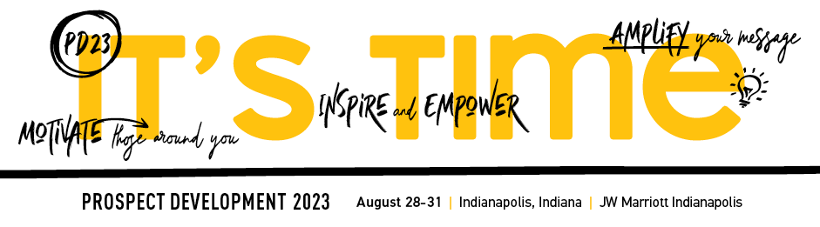

Prospect Development 2023 – Speaker Marketing Kit

Ensure a successful session by helping Apra build excitement around Prospect Development 2023. The following is sample copy you can share via email, on your website, in your email signature, with your social media networks and more to help induce excitement around your participation at Apra’s annual conference. As a speaker at this year’s event, you have an opportunity to influence your peers and colleagues and encourage them to attend. We appreciate your help as we work to make this the best conference yet!

Promotional Email

[Subject]
Join Me at Prospect Development 2023

[Body]
Dear [Recipient Name],

I’m excited to share with you that I will be speaking at Prospect Development 2023, taking place August 28-31 in Indianapolis, Indiana. I will be presenting [presentation title] on [date/time].

My session will cover:
- [Learning objective 1]
- [Learning objective 2]
- [Learning objective 3]

At Prospect Development 2023, attendees can choose from more than 50+ expert-led sessions (one of them being my own!), a selection of pre-conference events and more. Plus, you’re sure to pick up best practices from the conversations you have with the person sitting next to you during an education session or lunch break. The opportunities to learn are limitless!

Don’t miss the opportunity to network with like-minded peers at Prospect Development as attendees will have the chance to connect in the interactive Exhibit Hall, during Apra Talks and at the collaborative sharing sessions!

There is plenty of education information available, plus a customizable justification letter you can use to gain approval from your organization to attend. Be sure to secure your registration and hotel room before July 14 to receive the best rate.

I hope to see you in Indianapolis!

Best wishes,

[Email Signature]

Email Signature

Increase awareness of your participation at Prospect Development 2023 with your network of contacts by adding event information to your email signature. You may also choose to add the 2023 Prospect Development web banner below and hyperlink to https://www.aprahome.org/Events/Prospect-Development-2023.

Name
Title | Organization Name
Address 1, Address 2 | City, State Zip
P: +1.XXX.XXX.XXXX | E: e-mail@e-mail.com
Join me as I present at Apra’s Prospect Development 2023, August 28-31 in Indianapolis.

Web Banner

Post the above web banner to a high-profile page on your corporate website, blog, social media profile pages and email communications. Link the banner here: https://www.aprahome.org/Events/Prospect-Development-2023

Event Listing

Promote your participation at the conference by posting an event listing that highlights your presentation in your department’s or organization’s website or newsletter.
Prospect Development 2023
August 28-31
10 S West St
Indianapolis, Indiana 46204, US

Join Me at Prospect Development 2023!
Apra’s Prospect Development 2023 is the place to be for professionals in the prospect development industry. Whether your focus is prospect identification and research, relationship management, data science or anything else prospect development-related, this event has education tailored to your needs. Join me as I speak on [presentation title].

Register by July 14 to maximize your savings!

Sample Social Media Posts

Facebook/LinkedIn:

- Have plans this summer? I hope you’ll consider attending Prospect Development 2023, August 28-31 in Indianapolis. I’m speaking on [presentation title] and hope you’ll join me! https://www.aprahome.org/Events/Prospect-Development-2023

- The latest trends, topics and best practices in prospect research, data science and relationship management await you at Prospect Development 2023, August 28-31 in Indianapolis, including my presentation on [presentation title]. Learn more and secure your spot today: https://www.aprahome.org/Events/Prospect-Development-2023

Twitter:

- Join me at #ApraPD2023! I'll be speaking on [XXX]. See you in Indianapolis! https://www.aprahome.org/Events/Prospect-Development-2023

- Searching for a conference that will leave you energized and help both you and your organization? Join me at #ApraPD2023, where I’ll be presenting on [XXX]! https://www.aprahome.org/Events/Prospect-Development-2023

